🧪 LAB: High CPU Utilization (Create + Troubleshoot)

🎯 Step 1: Create the Problem (CPU 100%)
Run this in your Linux terminal:
yes > /dev/null &
👉 What this does:
- Runs infinite loop
- Consumes CPU

Check CPU usage:
top
👉 You’ll see:
- yes process using ~100% CPU
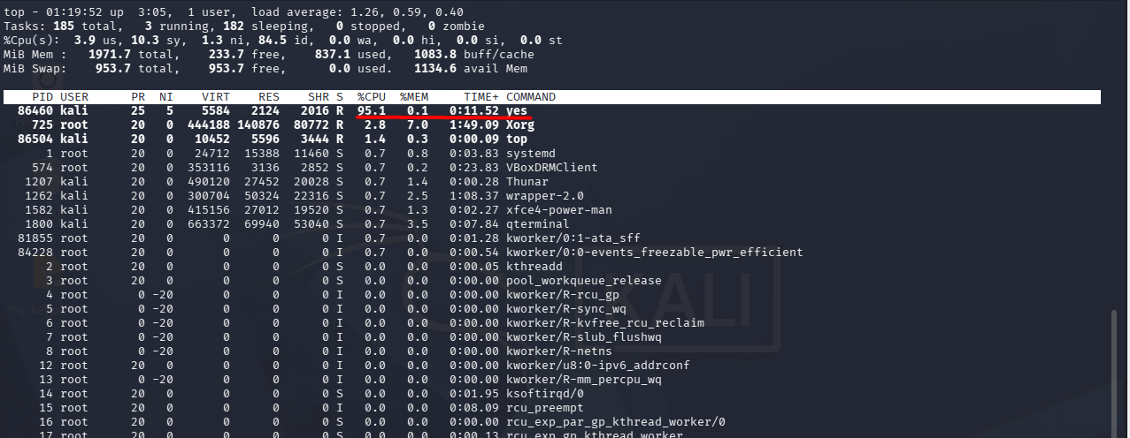

🔍 Step 2: Identify the Problem
Find process:
ps -ef | grep yes
or directly in top:
- Look for high CPU process
👉 Note the PID


🛠️ Step 3: Analyze Impact
Check:
- CPU usage (top/htop)
- System responsiveness
👉 Optional:
Uptime
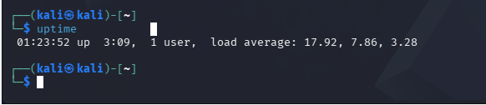

⚙️ Step 4: Control the Process
Option 1: Reduce priority
renice +10 86460
👉 Lowers CPU priority
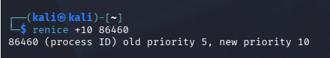

Option 2: Kill process
kill -9 <PID>
👉 Immediately stops it


🔁 Step 5: Verify Fix
Run:
top
👉 CPU should drop
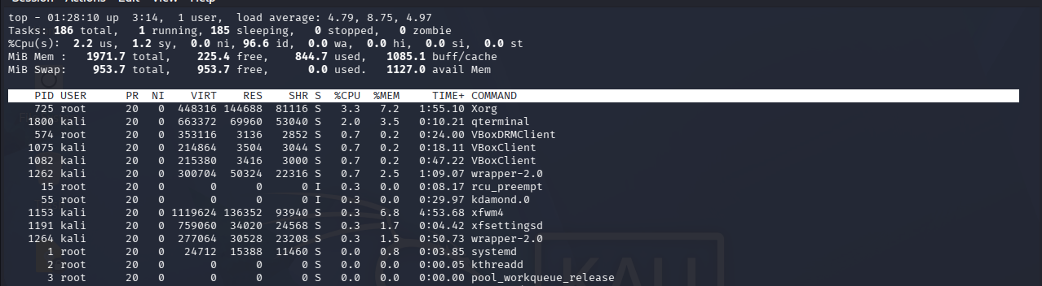

🧠 Step 6: Root Cause Simulation
Now create a fake “bad script”:
nano bad_script.sh
Paste:
#!/bin/bash
while true
do
echo "Running..."
done
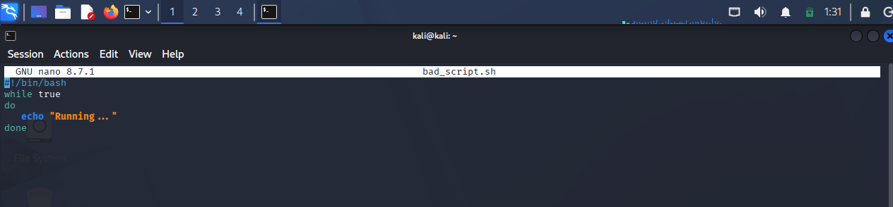
Run:
chmod +x bad_script.sh
./bad_script.sh &
👉 Again CPU goes high
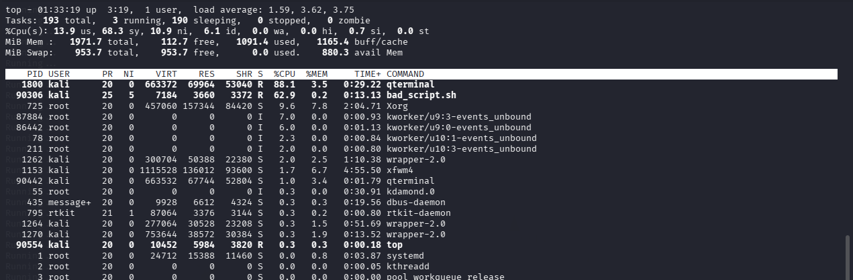

🔍 Step 7: Debug It
Check logs/output:
ps -ef | grep bad_script
👉 Problem:
- Infinite loop (no exit condition)
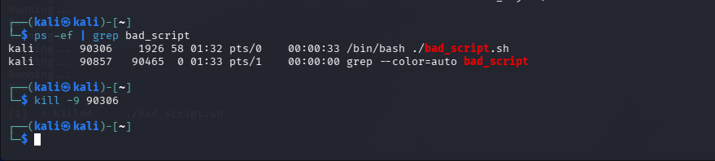

🛡️ Step 8: Fix the Script
Update script:
#!/bin/bash
for i in {1..10}
do
echo "Running $i"
sleep 1
done
👉 Now:
- Controlled execution
- No CPU spike

⚠️ What You Learned (Important)
✔ Identify high CPU
✔ Find process
✔ Control system
✔ Fix root cause
✔ Prevent recurrence

